# Project Document Information

|  |  |
| --- | --- |
| **Project name:** | Trekking App |
| **Date:** | 08/03/21 |
| **Authors:** | Software Project Team 9  118410722 Adam Evans  116451016 Eoin O’Connell  118332823 Oliwia Kobos  118359221 Pádraig Ó Cróinín  118476662 Adrian Lamug |
| **Product Owner:** | Jason Quinlan |
| **Version:** | v1.0 |
| **Colour Code:** | Newly added updates  Updates added from the peer review |

# Definition

|  |  |
| --- | --- |
| **Main Goal:** | To provide an easy to use mobile application for finding walking paths. |
| **Desired Outcomes:** | Easy to find trails near your location with the ability to customise the paths based on user needs. Ability to create new trails and save the trail’s statistics. |
| **Constraints and Assumptions:** | App will be available to mobile devices that have access to a working internet connection  User will confirm access to GPS location  Google Maps limitations to available routes  Current Google Maps API plan provides plenty of credits to use however when scaling the application, the costs scale as well. |
| **Interfaces:** | Google Maps, trails API |

# Key Stakeholders

|  |  |
| --- | --- |
| **Major Stakeholder** | **Notes** |
| **Jason Quinlan** | PRODUCT OWNER |
| **Adam Evans** | APPLICATION DEVELOPER   * Enabling the app to create push notifications * Creating a notifications tab |
| **Eoin O’Connell** | APPLICATION DEVELOPER   * Adding Maps fragment to app * Updating Project Brief |
| **Oliwia Kobos** | UI/UX DESIGN   * Designing the app’s UI * Implementing the UI design * Managing the Google Cloud project APIs * Creating product documentation |
| **Pádraig Ó Cróinín** | SOFTWARE TESTER   * Integrating Maps API with app * Working with Trails API * Managing given trails within the app * Displaying trails appropriately depending on user’s location |
| **Adrian Lamug** | SYSTEMS ARCHITECT   * Implementing the UI design * Setting up a database for the app * Implementing navigation between app fragments * Configuring app permissions * Retrieving and using the user’s location |

# Project Objectives

|  |  |  |
| --- | --- | --- |
|  | **Target** | **Tolerance** |
| **Scope** | Ideally hitting our MoSCoW targets | Hitting just the must targets |
| **Time** | 7 weeks | 8 weeks |
| **Cost** | Hopefully no costs will arise |  |
| **Quality** | A polished, working product |  |
| **Risks** | Using up Google Maps credits |  |
| **Benefits** | An application including as  many of our intended as possible | An application which only offers users the features mentioned in the Must-Have section of the MoSCoW |

# 

# Outline Business Case

Since the introduction of lockdown measures due to Covid-19 many people are finding themselves spending more time than normal at home. Therefore, there is a bigger interest in making up for lost movement through exercising at home. Our application identifies the possible market of mobile users who are stuck in the same monotonous routine that makes walking seem more burdensome than necessary.

The Trekking App intends to use the readily available Google Maps API to create and track customisable routes, allowing users to have a new experience every time they venture outside. Users can avail of features such as filters that allow them to set the maximum or minimum distance of a route, adhering to the exercise guidelines established. The application can include scenery or places of interest during the walk, tap into local weather news to predict path conditions, track user stats, and more.

Unlike other applications on the market, the Trekking App’s main benefit is in combining both rural and urban landscapes, minimising the need for major travel and creating something available to all without limiting features based on someone’s locations.

# Product Description

Our project is a reaction to the health crisis being caused by the covid-19 pandemic. In order to try and promote exercise and help people get out of their homes to destress we plan on creating a mobile app that will pick out walking paths for people that abide by the Covid-19 guidelines at the time.

This application will serve as a recommendation guide for the user to make their walk more interesting, not as a navigation system to get from place A to place B. Therefore it is up to the user’s discretion on how closely they choose to follow the path.

Walking paths will be presented to users in relation to their own location. Their travel limit will be displayed to the user graphically. Trails will clearly show whether they are within, or outside of the user’s travel limit.

Users will also be able to create their own custom trails. The user’s statistics will also be saved with these trails. Time, distance and speed will all be stored along with the route the user took.

**Must-Have Features**

* Trail suggestions should not be over 5km away from the user’s home ✓
  + Displays 5km perimeter around user’s location ✓
  + Trails highlighted differently depending on if they are in the user’s 5k or not ✓
* GPS tracking during the course of the route, and upon completion of trail ✓
  + Track user’s location and can compare with coordinates along trail ✓
* Favourites tab containing saved trails. ✓
  + Saved Trails tab of user’s created trails ✓
* Notifications (Covid-19 updates, weather warnings)

**Should-Have Features**

* The app should have a feature for the user to filter route types such as “Scenic Routes”.
* Path creator feature which would allow the user to create the trails manually (Moved to Could-haves) ✓
  + User location taken at intervals and used to draw a trail ✓
  + Database setup within app for trail storage ✓
* Option to filter by rating and popularity and length of the trail.
* Track user stats such as steps taken, distance travelled, average pace, etc.
  + User steps are successfully tracked ✓
  + Database setup within app to track user stats on particular trails ✓
* User performance report at the end of each week.

**Could-Have Features**

* Path sharing feature
* Option to share performance on social media
* “Marathon Mode” could allow a user to build up longer walking or running distances.
* Keep track of trail traffic.

**Won’t-Have Features**

* Offline support. We shall have to make assumptions that any user with access to our mobile application will also have access to Wi-Fi and mobile data.
* Caching the trails before the user goes on walks.

**Project Architecture:**

The interfaces that the application will be interacting with are the Trails API as well as the Google Maps API. Using a user’s location, Google Maps should filter trails from the Trails API, and return to the user the appropriate trails.

The initial architecture plan (shown in Figure 1) has changed. In order to comply with GDPR and to ensure confidentiality, the user’s location will not leave their device. We realised that our team does not have the expertise to ensure compliance with GDPR guidelines, if we were to begin storing the user’s location. All trails will be stored locally on the user’s device. The work will then be done locally to calculate, using the user’s location, which routes are appropriate. These routes will then be visualised using Google Maps. The user’s location will not leave their device. These architectural changes are reflected in Figure 2. If this changes in future than other concerns will arise regarding secure storage of users data.

Figure 4 displays the overall architecture of the project. This diagram was agreed upon after each team member created architecture diagrams based on their own perspective. Figure 4 is the agreed result of these diagrams combined.

**Sequence Diagram**

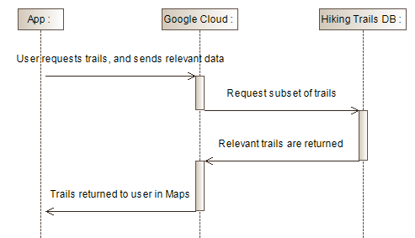

*Figure 1: Initial Sequence Diagram idea. User’s location would be sent to Google Cloud which would fetch relevant trails.*

**New Sequence Diagram**

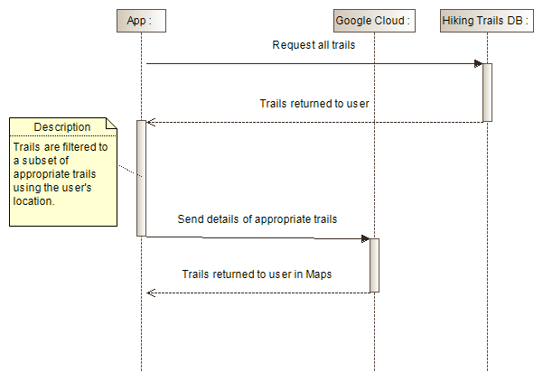

*Figure 2: Revised Sequence Diagram idea. User’s location does not leave their device, but instead all trails are kept locally and filtered locally. This change was made to avoid GDPR issues*

**USER STORIES**

*Figure 3: Updated User Stories for the project.*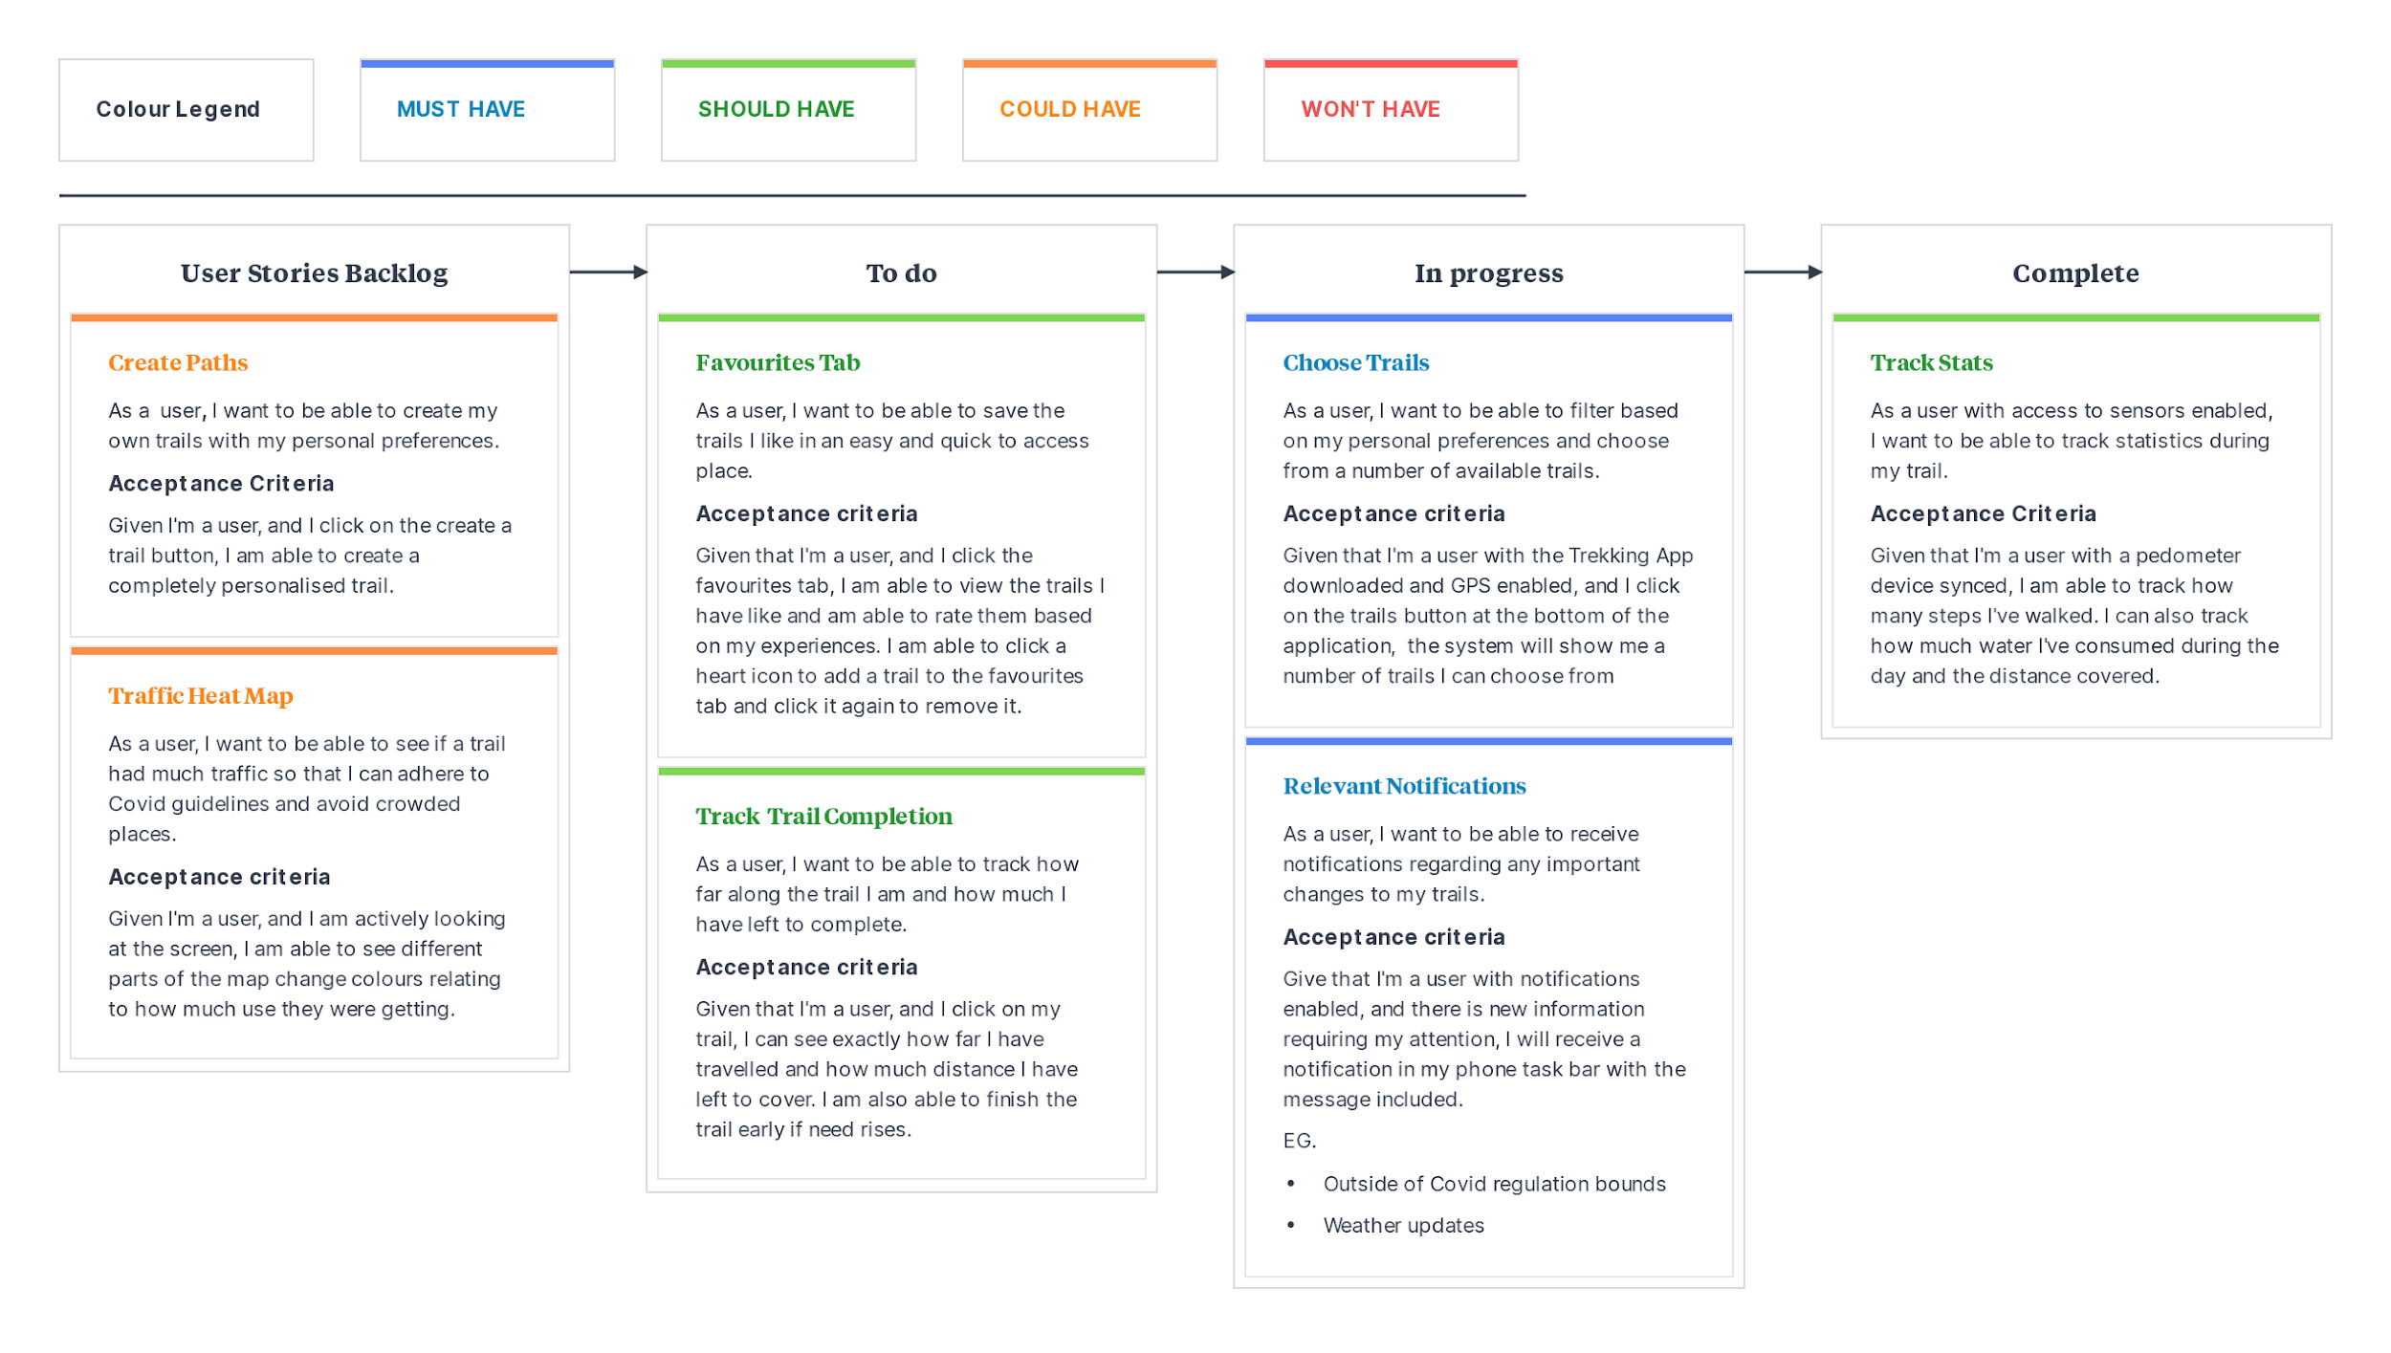

**Overview Diagram:**

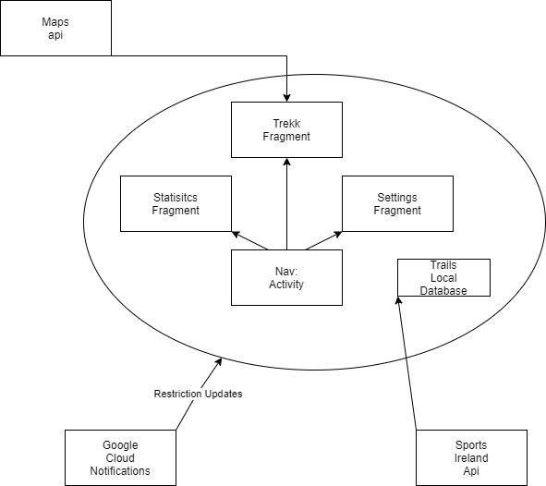

*Figure 4: Overall architecture diagram of the project, showing different components interacting*

# 

# Gantt Chart:

**Short-term Gantt:**

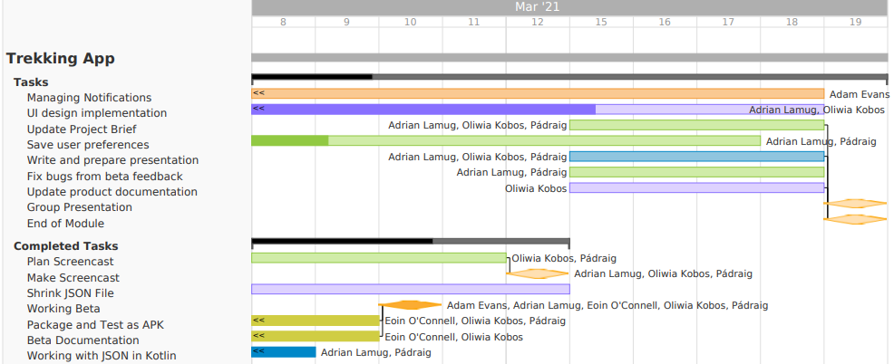

**Forecasting Gantt:**

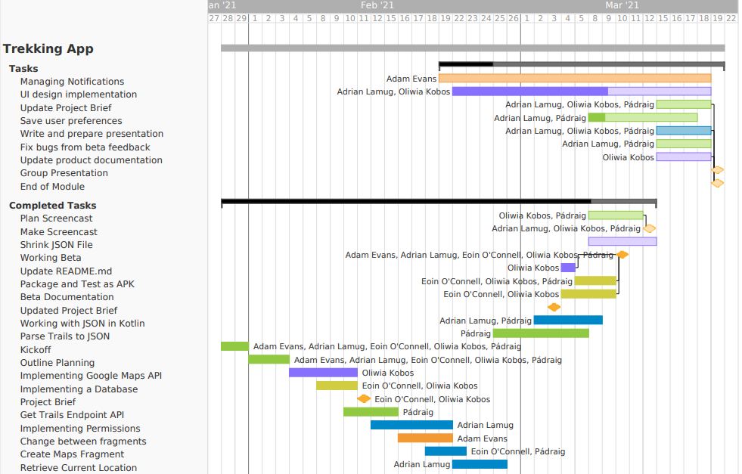

# Response to Beta Feedback

* Poor performance on android device:

Performance problems have been fixed. Slowdowns should be much rarer when navigating the map in the “Your Trails” section. Some random crashes still occur. The most frequent are documented in the “Known Bugs” section of the documentation.

Conclusion: Partially Resolved

* Poor performance on Android Studio

Android Studio and its android emulator perform poorly on most machines. This is not something we could address, and is an issue that plagued us during development.

Conclusion: Unresolved

* Name is wrong (My Application instead of Trekker)

This has been fixed. However if the app is already installed on your device it must be uninstalled in order for the name to be changed.

Conclusion: Resolved

* Our logo is not original but take from Twitter’s emoji library

Proper attribution given in readme file.

Conclusion: Resolved

* Welcome screen doesn't save your name

User’s name which is entered upon startup, is now saved within the app.

Conclusion: Resolved

* Can’t change user name in settings

The user name can now be changed in settings.

Conclusion: Resolved

* Some instructions for installation of Android Studio were outdated.

More detailed instructions are now given in the Readme. Specific sections of pages are referred to. Parts of the instructions show an outdated UI, and this is mentioned. The steps shown in those instructions are still correct.

Conclusion: Resolved

* Save user accounts

This piece of feedback recommended using Google Firebase to have online accounts for users. This is the major next step for our application, which we could not implement within our timeframe. This is discussed further in the Possible Future Developments section.

Conclusion: Unresolved

# Possible Future Developments

* The main future development would be enabling users to share their data. This would be accomplished by use of Google Firebase. Within our time constraints we could not begin working with Firebase. Had we begun to integrate Firebase services in to the application, these are the next features we would have looked to include:
  + External notifications, informing the user of changes in Covid-19 guidelines and weather warnings
  + Enabling users to create accounts, which then store their data. Stored data would include user statistics and their created trails
  + Allow users to share created trails with others, as well as share and compare their statistics with other users.
  + Updating the existing trails which come with the app

# Final Product

* All of the must haves of the project have been met, bar one
  + The user is presented with trails complying with the current travel limitations
  + The user can see their location in relation to a trail to track their completion of it
  + A separate tab of saved (or favourite) trails is available in the app
* The app lacks external notifications relating to Covid-19 restriction updates and weather warnings. This would have required the use of Google Firebase. This is further discussed in the Possible Future Developments section.
* Some of the should-have features have also been met
  + Trails can be created manually and will be saved to the users device
  + User statistics are tracked through a pedometer
* One additional feature which was not featured in the MoSCoW was added:
  + The ability to get directions to the start of the trail. Directions open within Google Maps
* Our initial target for a successful product was to meet all of our must-have goals. We met all of those goals, with the exception of the inclusion of external notifications. This could be seen by some as “moving the goalposts”, but in conclusion we would still consider this project a success. The application lacks polish and its performance is poor, with crashes frequent. The team’s inexperience in android development is clear to see. These issues make the current version of the app unreliable and difficult to recommend for real world use in its current state. However, the application delivers on its primary purpose. It offers many of the features the team had intended, and is a product with considerable potential and vision behind it.